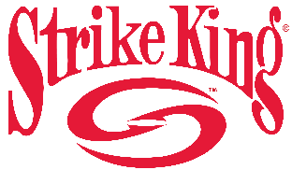

2022 Big Bass Challenge Info Sheet
Lake Cumberland
Burnside, KY

Tournament Date: 3/27/22
Lines in at 7:15am EST
Take Off Location
Anywhere on Lake Cumberland

Weigh Site
Burnside Island State Park
8801 S. Highway 27
Burnside KY 42519 (fish must come to the weigh-in site by water)

Weigh Periods
7:30am – 8:59am
9am – 10:59am
11pm – 12:59pm
1pm – 2:59pm

Guaranteed Payout Each Pay Period
Place | 1-199 anglers | 200+ Angler Bonus | 300+ Angler Bonus
1st | $ 750.00 | $250 | $350
2nd | $ 450.00
3rd | $ 300.00
4th | $ 225.00
5th | $ 150.00

Prize Drawings for fish weighed each period from each of the following companies:

“Total Boat Makeover” Grand Prize for heaviest bass: $5,000 Gift Card for use on Strike King or Lew’s product

Pro Night, Gift Card Pickup & Onsite Registration
Burnside Island State Park
Date: 3/26/22
Time: 4pm – 7pm

*FREE Lew’s Strike King Gift Card for first 100 to pre-register. Must be picked up onsite 3/26/22

