2022 Big Bass Challenge Info Sheet
LAKE ERIE
Sandusky Ohio

Tournament Date: 4/24/22
Lines in at 6:30am EST
Take Off Location
Anywhere on Lake Erie

Weigh Site
Shelby Street Public Launch Ramp
101 Shelby Street
Sandusky, OH (fish must come to the weigh-in site by water)

Weigh Periods
7am – 8:59am
9am – 10:59am
11pm – 12:59pm
1pm – 2:59pm

Guaranteed Payout Each Pay Period
Place | 1-199 anglers | 200+ Angler Bonus | 300+ Angler Bonus
1st | $ 750.00 | $250 | $350
2nd | $ 450.00
3rd | $ 300.00
4th | $ 225.00
5th | $ 150.00

Prize Drawings for fish weighed each period from each of the following companies:
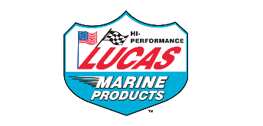

“Total Boat Makeover” Grand Prize for heaviest bass: $5,000 Gift Card for use on Strike King or Lew’s product

Pro Night, Gift Card Pickup & Onsite Registration
Paris Landing Marina
Date: 4/23/22
Time: 4pm – 7pm

*FREE Lew’s Strike King Gift Card for first 100 to pre-register. Must be picked up onsite 4/23/22

